**A Comparative Analysis of Machine Learning Algorithms**

**Indrashis Mitra, Souvik Karmakar , Sudeshna Dutta, Kinjal Sarkar and Pratyay Basu**

**Guided by: Dr.** [**Kananbala Ray**](mailto:kbrayfet@kiit.ac.in)

***Abstract -*** In today’s population aging scenarios in the developing countries, there is an epidemiological and demographic transition which is affecting the health state of the entire population. Healthcare sectors have boosted immensely in terms of science, technology and services in the recent few decades. The next big change that is to skyrocket this field in terms of quality, efficiency and quantity is the introduction of ‘Automation’ in these sectors. With the assistance of IOMT we are targeting a large part of the population to get the diagnosis readily available at cheaper rates even when some medical professional is absent. Data by various metrics monitoring sensors are sent to the cloud via a Wi-Fi module and then displayed remotely which assures saving of the crucial golden hours of the patient. Now patients themselves can monitor their health parameters, sitting at home which will increase the efficiency of the healthcare sectors and industries. Overall by implementing this technology in the near future people can effectively reduce the hassling circumstances and not only unlock but also boost the true potential of the healthcare systems which ultimately will be a boon to mankind.

***Index Terms -*** Temperature,IOT,Android,Microcontroller,ESP8266 Wi-Fi Module,IFTTT

1. INTRODUCTION

The Internet of things is used to interconnect devices, apps,sensors and network connectivity that enhances these entities to gather and exchange data. IOT has distinguished characteristics which are very helpful in the healthcare domain to constantly monitor patients.It is possible to check various parameters recorded by different types of sensors and infer results from their time varying nature. There are quite a few problems in the healthcare domain such as delay in alerting doctors in an emergency situation of a continuously monitored patient, hindrances in consultation and sharing information with specialists ,family members and relatives,to name a few. The technology that solves these problems is already available but not accessible and affordable by most of the people. Hence solutions to these problems can be just a simple extension to the current devices which don’t have these facilities.

In this project we have designed a system to continuously monitor vital parameters such as heart rate and body temperature. The information is stored on a cloud server database uploaded by Node MCU and can be displayed through an online dashboard or mobile application to authorized personnel only. The main objective of this system is to update the data online and send an alert to the doctors for any abnormality so that serious patients can receive treatment on time. In addition to this we have worked on a mechanism to detect and alert caretakers if an elderly person accidentally falls down,so that they receive help on time.

1. LITERATURE REVIEW

The authors proposed a health monitoring system that monitors the heart rate and temperature of the patients along with some environmental parameters that are measured by room-temperature sensor, CO sensor and CO2 sensor. The acquired data is transmitted over wireless networks, maintained in a single database of patients, giving an alert to the authorities, aside from personalization of critical health-related criteria. The verified medical team collects the raw data, analyzes, makes and makes decisions virtually using the data, without meeting in person.

Authors have done a comprehensive study on the recent advancements in IoT-based healthcare technologies, the IoT network architectures/platforms, applications, and industrial trends. They have also analyzed several other IoT security and privacy features,which includes threat models, security requirements and attack taxonomies, when taken from the perspective of the healthcare industry. Further, to face the challenges for future research on IoT based healthcare, they have proposed a smart collaborative security model that considerably lessens security risk; explains how innovations like big data, Machine learning, ambient intelligence, and wearables technology that can be leveraged in a health care context.

The authors proposed a system that effectively monitors pulse rate in real time. The sensor, connected to the Microcontroller in Arduino UNO acts as a data source which is acquired by the sensor node. Then this data is pre-processed and labelled. This can then be relayed to the cloud/database(ThingSpeak) for the additional scope of appropriation in data analysis. This data is taken to observe the parameters for the future observation, predictions etc.

1. BASIC CONCEPTS

**Embedded Systems**: Embedded systems have long been part of the development of medical devices . Our main objective in this project is to ensure patients get ample attention regarding their health which sometimes becomes difficult when the patient stays at home . Also in this Covid scenario where the hospitals are already overwhelmed with covid patients it will be easy for patients as well as doctors if they can monitor the patients from their home itself .

As a result we have divided this project into two specific parts -

1. **Health monitoring system** - In this part of the project we monitor the temperature and the pulse of the patient. We use MLX 90614 for temperature measurement and MAX 30102 for pulse monitoring of the patient. Keeping in mind the recent Covid scenario, if the patient has a high temperature then it will automatically be shown on the online dashboard, where the doctors can get the data of the patient. Same goes for the pulse sensor if the pulse becomes too low or high then the doctors or the family members of the patient can monitor it too. We designed a small wearable module where both the temperature and the pulse rate will be displayed. This module is also used for fall detection.
2. **Fall Detection system** - Fall Detection is really important for elderly people where falling and not getting up can be fatal sometimes. To minimize that we used an MPU6050 module which helps us to detect a fall using an accelerometer and gyroscope. The sensor will be inside the wearable and will send message notifications to the family members or the number that will be registered. Within a designated time if the person is not picked up the message will be sent again.

**Internet of Things (IOT)** : The core area of ideation was to display the data collected by the sensors in an interesting and understandable way, for which we intend to use 2 platforms - website and mobile application. For the website we plan to build a dashboard using thinger.io, which is a free, open-source cloud IOT platform that has a variety of features to make effective and easily manageable dashboards. By specifying the various connections and widgets, we intend to build a dashboard as shown in the fig. This is done so that the parameters can be monitored whether they remain in the threshold limits and a generic person can also understand the fluctuations in the measured values by viewing the graphical representation of the measured values on the dashboard.

Blynk was originally developed for the Internet of Things. It can control hardware remotely, it can display sensor data, can store and visualize data and is useful for various other purposes. The parameters that are being monitored by the different sensors are visualized remotely via the Blynk app. This allows a quality GUI experience for the customers i.e. the relatives and family members of the patient. By using the Blynk app anyone who is shared with the QR code can download the app and it will contain the required project for metrics monitoring. This approach will reduce the amount of panic within family members and will provide a suitable environment and time duration for the best possible treatment of the patient.

IV. IMPLEMENTATION AND RESULTS

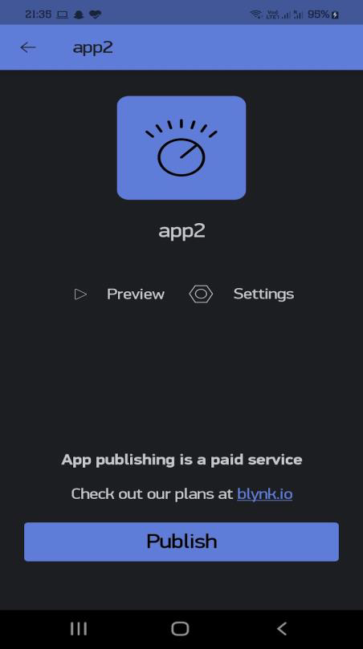 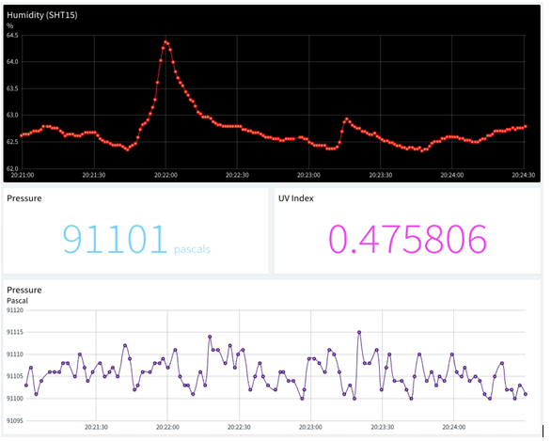

*Fig - Visual representation of dashboard and blynk app*

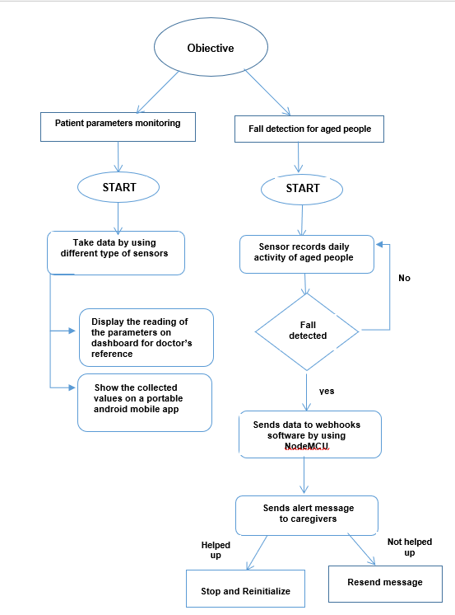

*Fig . - Flow diagram*

1. CONCLUSION

We have mainly focused on two objectives. The first one was a medicine recommendation system that will be helpful for the healthcare sector. People won’t have to face the problem of unavailable medicines, since the stores will be stocked well in advance since they can know which medicines are most likely to be bought. Moreover, the economy will be helped since the medical black market will be eliminated as medicines are readily available so there is no shortage, thus no scope of dishonest people to dupe others by profiteering from selling medicines at exorbitant rates to needy people. Secondly, our focus is on the study and comparison of various classifiers. We have taken 5 classifiers and processed the same dataset containing DNA sequences through each of them, so that we can understand which classifier works best in our case.

REFERENCES

[1].J. Bouwens, “Embracing Change: The healthcare industry focuses on new growth drivers and leadership requirements.”

[2]. "Intro to Machine Learning | Udacity." Intro to Machine Learning | Udacity. Accessed April 27, 2016.

[3]. Thanh Nguyen, Abbas Khosravi, Douglas Creighton, Saeid Nahavandi,

Classification of healthcare data using genetic fuzzy logic system and wavelets,

Expert Systems with Applications, Volume 42, Issue 4, 2015, Pages 2184-2197

[4]. Schölkopf, Bernhard, Christopher J. C. Burges, and Alexander J. Smola,Advances in Kernel Methods: Support Vector Learning. Cambridge, MA: MIT Press, 1999.

[5]. Witten, I. H., and Eibe Frank. Data Mining: Practical Machine Learning Tools and

Techniques. Amsterdam: Morgan Kaufman, 2005

[6]. Zhiyong Ma, Juncheng Yang, Taixia Zhang, Fan Liu. (2016). An Improved Eclat Algorithm for Mining Association Rules Based on Increased Search Strategy. International Journal of Database Theory and Application, 9(5), 251-266

[7]. Yoo I, Alafaireet P, Marinov M, Pena-Hernandez K, Gopidi R, Chang JF, et al. Data mining in healthcare and biomedicine: a survey of the literature. J Med Syst 2012; 36:2431–48.

[8]. Yadav M, Malhotra P, Vig L, Sriram K, Shroff G. Ode-augmented training improves anomaly detection in sensor data from machines. arXiv preprint arXiv:1605.01534,2016:1–5.

[9]. Hastie, Trevor, Robert Tibshirani, and J. H. Friedman. The Elements of Statistical

Learning: Data Mining, Inference, and Prediction: With 200 Full-color Illustrations. New York: Springer, 2001

[10]. O.Stephen et.al.,”An Efficient Deep Learning Approach to Pneumonia Classification in Healthcare”,Journal of Healthcare Engineering ,Volume 2019

Monitoring System